| Date | 29 October 2022 |
| --- | --- |
| Team id | PNT2022TMID23204 |
| Project name | Real Time River Water Quality Monitoring And  Control System |
| Maximum marks | 20 marks |

Step1 : creating IBM cloud and Using its service

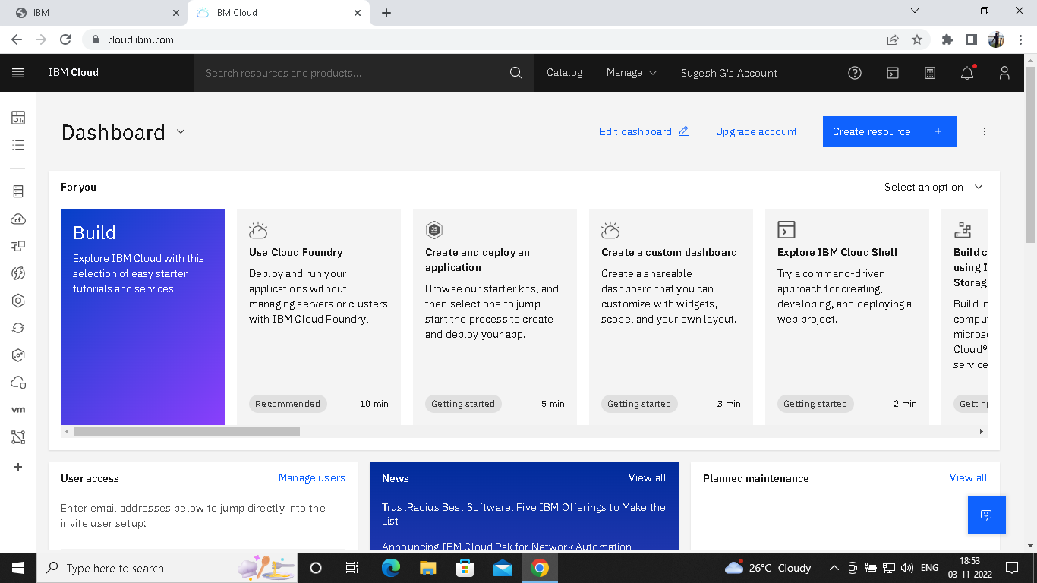

Step 2:Configure the IBM cloud service and creating IOT platform

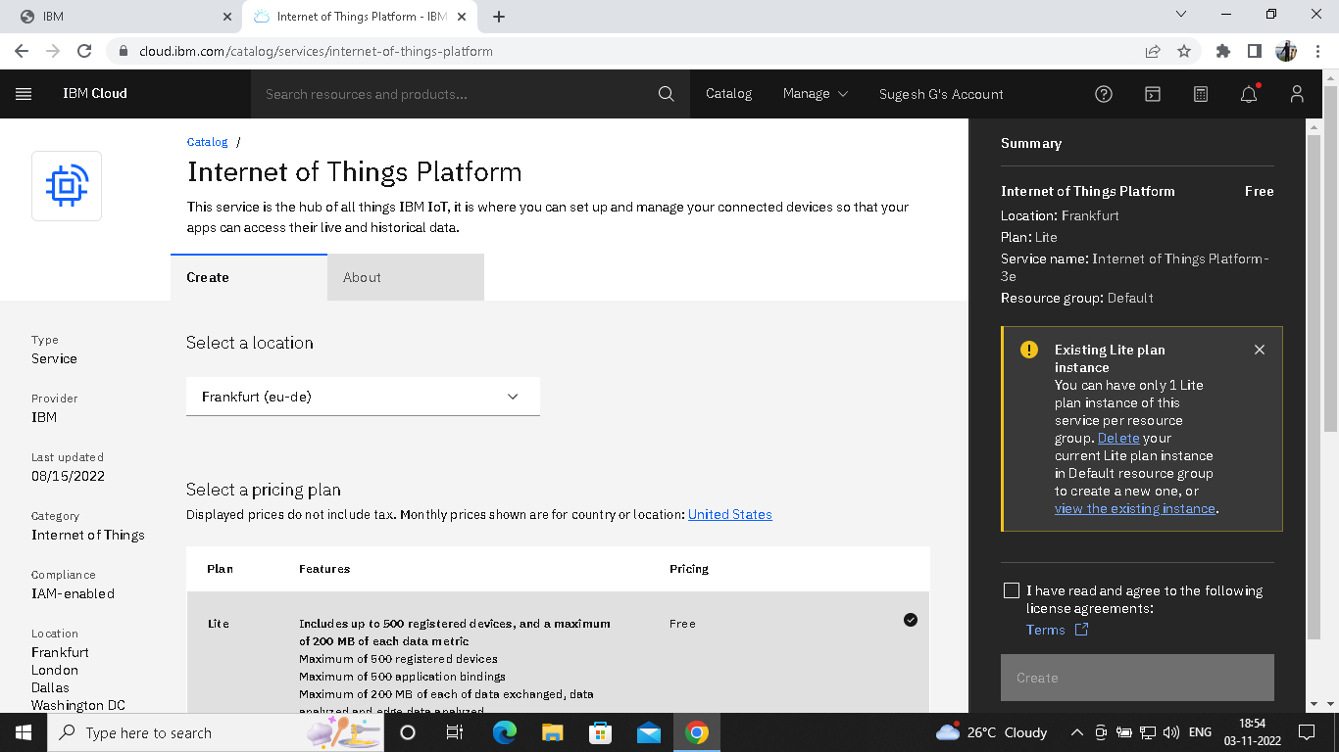

Step-3: IBM Watson IOT platform acts as the mediator to connect the web application to IOT devices,

hence launching IBM Watson IOT platform.

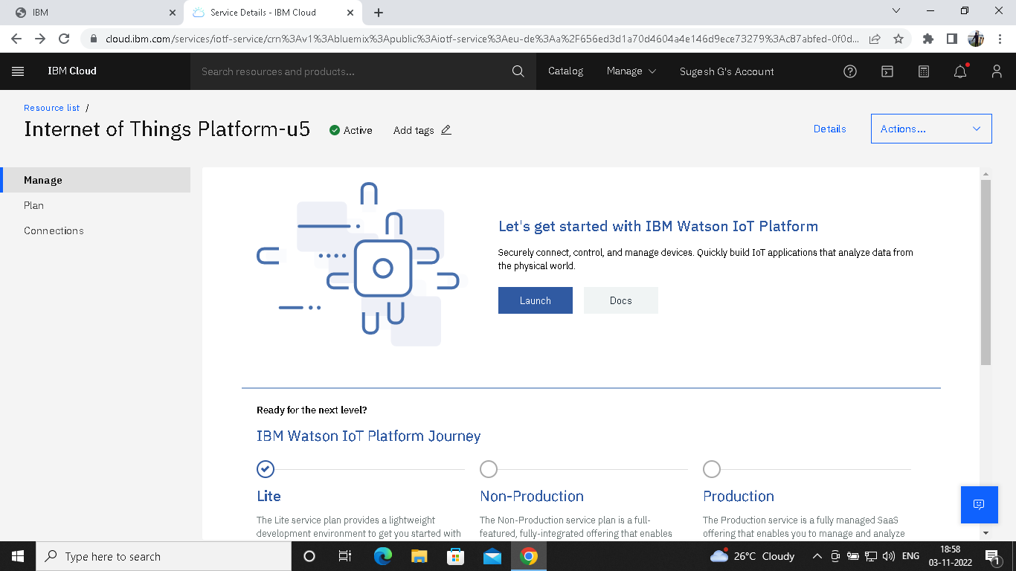

Step-4: IBM Watson IOT platform is created

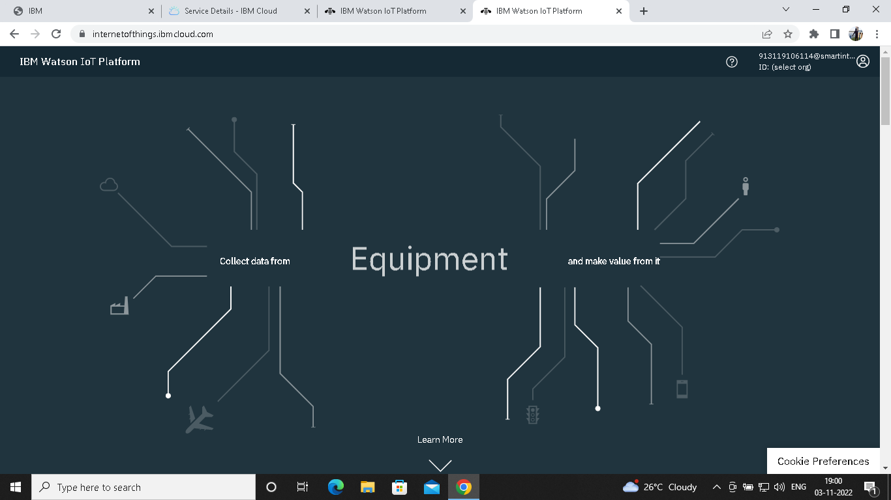

Step-5: In order to connect the IOT device to the IBM cloud ,create device in the IBM Watson IOT

Platform and get the device credentials.

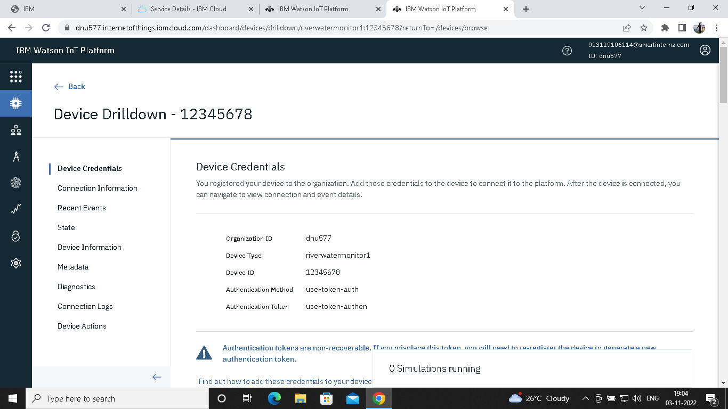

Step-6: Connect the device and start simulating.

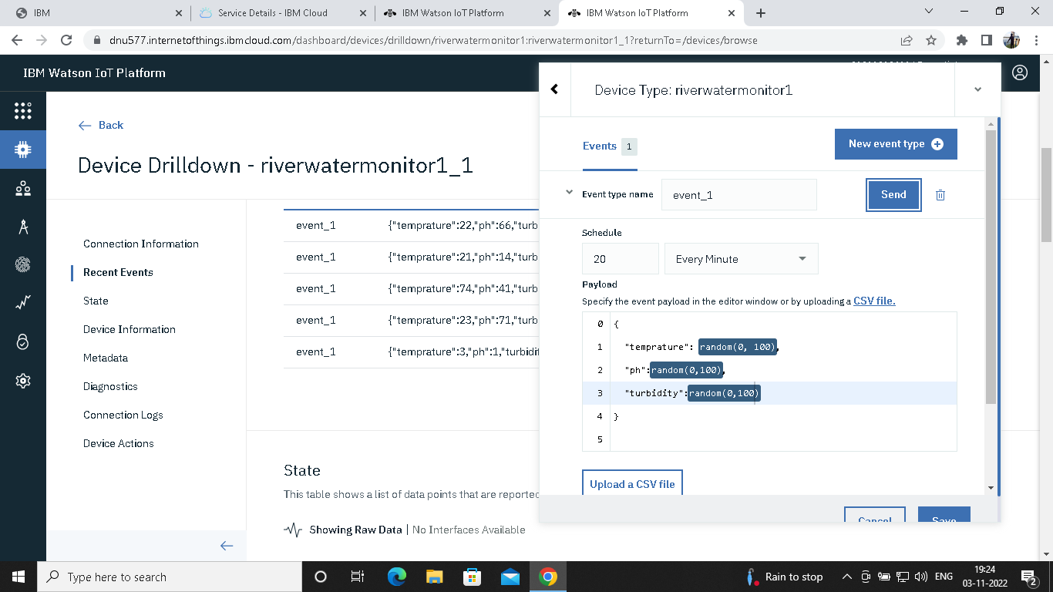

SIMULATION:

The simulation shows the Temperature, pH and Turbidity value.

